# AMME5790: BIOMECHATRONICS

# ACTIVITY: ECG Interface

Name: Hunter Tambimuttu SID: 510448271

Name: Caleb Nazareth SID: 530372811

Name: Gabriel Ralph SID: 470205736

Note: This activity needs to be completed and submitted by the end of the week

## Hardware

|  |  |  |
| --- | --- | --- |
| Item | Reference Number | Returned (signed by Tutor) |
| DT9835 Module with PSU and USB cables |  |  |
| B&L Eng 6 channel EMG interface module |  |  |
| B&L Eng EMG pre-amplifier |  |  |
| Short BNC cable (Pigtail) |  |  |
| Desktop running DT Measure Foundry |  |  |

## Reading

Notes on Electrocardiology

## Background

The goal of this activity is to develop the rudiments of measuring Electrocardiograph (ECG) signals to investigate ventricular depolarisation as a function of angle



Figure 1: Ventricular Depolarisation

The orientation of each lead-pair of a conventional ECG views ventricular depolarisation from a different angle, therefore the shape of the QRS complex will be different in each case as determined by the direction of ventricular depolarisation and the orientation of the heart.

If the depolarisation signal is propagating in the direction of the axis (as shown by the arrow), then the waveform generated will be positive. If it is travelling in the opposite direction, the waveform will be negative. Finally, if the depolarisation wave is travelling at right angles to the axis, a bipolar “equiphasic” signal will be observed

A rotation of the depolarisation axis can be indicative of a problem, as shown in Figure 2.



Figure 2: Potential pathologies relating to axis deviation

## Setting up the Activity



**Figure 3: Wiring for the ECG Activity**

The ECG amplifier is plugged into the B&L interface module. This connects battery power to the amplifier, and connects the amplifier output to the BNC socket

Channel 1 of the B&L interface module is connected to AD Ch0 through the short BNC cable

The USB port from the PC is plugged into the DT module

Power is provided to the DT module

## Developing the Measure Foundry Software

Using the Microphone Test.MFProj Project as a template, develop an interface for ECG signals

The project should include the following features:

* Switch
* Oscilloscope displays for the ECG signals before and after filtering
* Noise filtering
* Spectrum Analyzer to determine the spectral content of the signal
* Counter to display pulse rate (not shown here), optional but will be worth bonus marks



**Figure 4: ECG screen capture showing a typical waveform**

**Activity**

**Measure the ventricular depolarisation axis for a number of subjects**

* Placing the electrode over the heart, rotate it until you obtain a symmetrical trace. This is the equiphasic “lead”. Identify the axis from Figure 1, label the axis and cut and paste the trace in the box below. (10)
* Rotate the electrodes by about 90° and confirm that the QRS trace looks conventional. Identify the axis and cut and paste the trace in the box below. (10)

|  |  |  |  |  |
| --- | --- | --- | --- | --- |
| Axis | Subject 1 | Subject 2 | Subject 3 | Subject 4 |
| -aVL |  |  |  | If available |
| II |  |  |  | If available |

Do these results show that the depolarisation axis is positive, and in the “normal” quadrant? Briefly comment on any anomalies. (3)

Insert comments here

**Stress Test**

Select a single reasonably fit subject from your team

With the electrodes aligned along the II axis, cut and paste the waveform and measure the resting heart rate. (5)

Keeping the electrodes firmly held in position, perform 30 repeats of the stair climbing exercise

Cut and paste the waveform and measure the stressed waveform heart rate (5)

Repeat for an unfit subject from your team (10)

|  |  |
| --- | --- |
| Fit person rested | Fit person stressed |
| 78bpm | 70bpm |
| Unfit person rested | Unfit person stressed |
| 100bpm | 115bpm |

**Group Stress Test**

If you are healthy, perform 30 repeats of a step climbing exercise, then measure your heartbeat for 10s every 30s for 5 minutes and record it in the attached table. You probably want a reader and a scribe to complete each of these tests. Alternatively, if a pulse oximeter is available, then use one of those. Copy the data from other groups to complete your table if you wish (20)

All measurements in BPM

|  |  |  |  |  |  |  |  |  |  |  |  |  |  |  |  |
| --- | --- | --- | --- | --- | --- | --- | --- | --- | --- | --- | --- | --- | --- | --- | --- |
| **Time (min)** |  | **A** | **B** | **C** | **D** | **E** | **F** | **G** | **H** | **I** | **J** | **K** | **N** | **O** | **P** |
| **0 (resting)** |  | 95 | 63 | 72 | 65 | 123 | 56 | 93 | 80 | 75 | 49 |  | 75 | 112 | 72 |
| **0.5** |  | 122 | 106 | 126 | 108 | 127 | 59 | 118 | 111 | 113 | 60 | 100 | 110 | 98 | 94 |
| **1** |  | 103 | 79 | 122 | 75 | 114 | 62 | 99 | 99 | 90 | 47 | 95 | 95 | 78 | 81 |
| **1.5** |  | 97 | 67 | 99 | 65 | 75 | 53 | 98 | 98 | 81 | 48 | 88 | 88 | 74 | 76 |
| **2** |  | 91 | 64 | 87 | 57 | 83 | 53 | 86 | 59 | 70 | 51 | 80 | 65 | 77 | 80 |
| **2.5** |  | 101 | 63 | 85 | 49 | 86 | 71 | 85 | 64 | 88 | 48 | 83 | 61 | 89 | 68 |
| **3** |  | 91 | 67 | 94 | 70 | 86 | 65 | 85 | 85 | 73 | 51 | 78 | 79 | 89 | 70 |
| **3.5** |  | 78 | 66 | 90 | 77 | 83 | 61 | 86 | 94 | 84 | 48 | 81 | 84 | 86 | 66 |
| **4** |  | 76 | 65 | 89 | 59 | 98 | 62 | 83 | 80 | 78 | 50 | 76 | 66 | 84 | 67 |
| **4.5** |  | 95 | 65 | 80 | 58 | 96 | 58 | 80 | 67 | 91 | 52 | 80 | 76 | 85 | 73 |
| **5** |  | 94 | 63 | 80 | 76 | 97 | 58 | 79 | 69 | 95 | 52 | 74 |  |  | 74 |

Convert to beats per minute (bpm) and plot all the data on graph showing bpm vs Time (10)

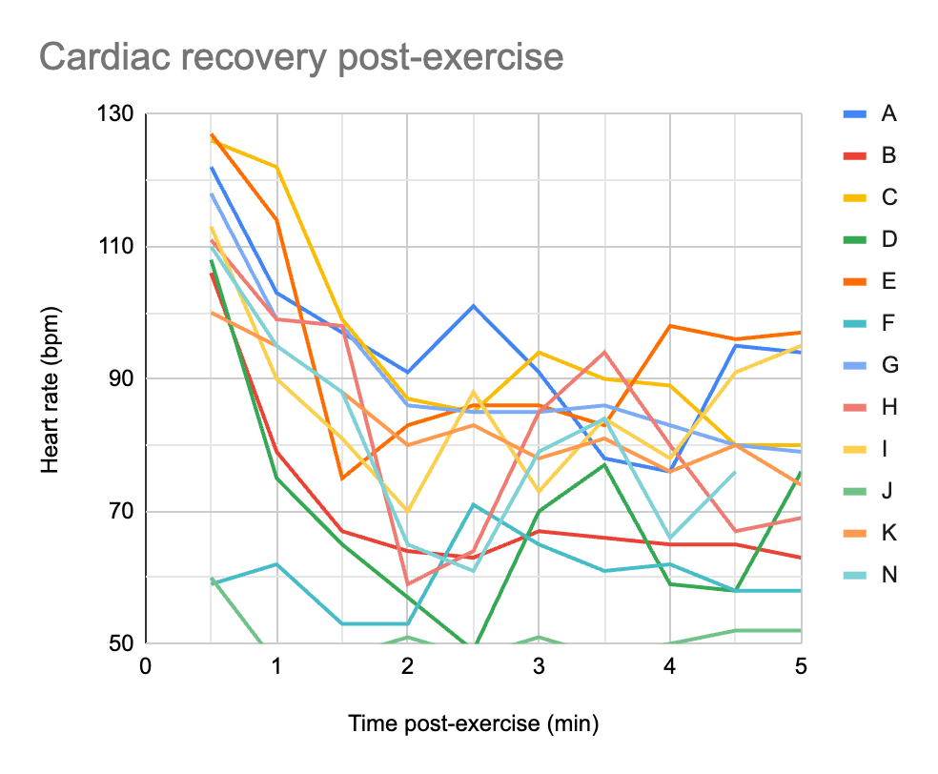

Total (73)